# **Creating an S3 Bucket for Static Website Hosting**

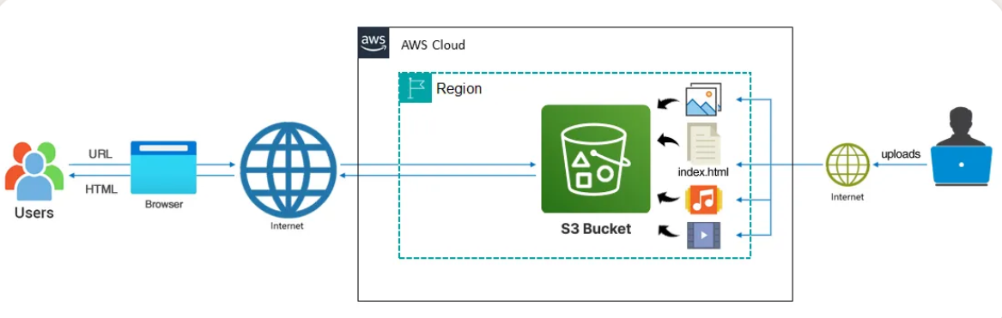

1. Navigate to S3 in AWS Console

• From the AWS Management Console, search for “S3” in the top bar.

• Click on “S3” under Storage.

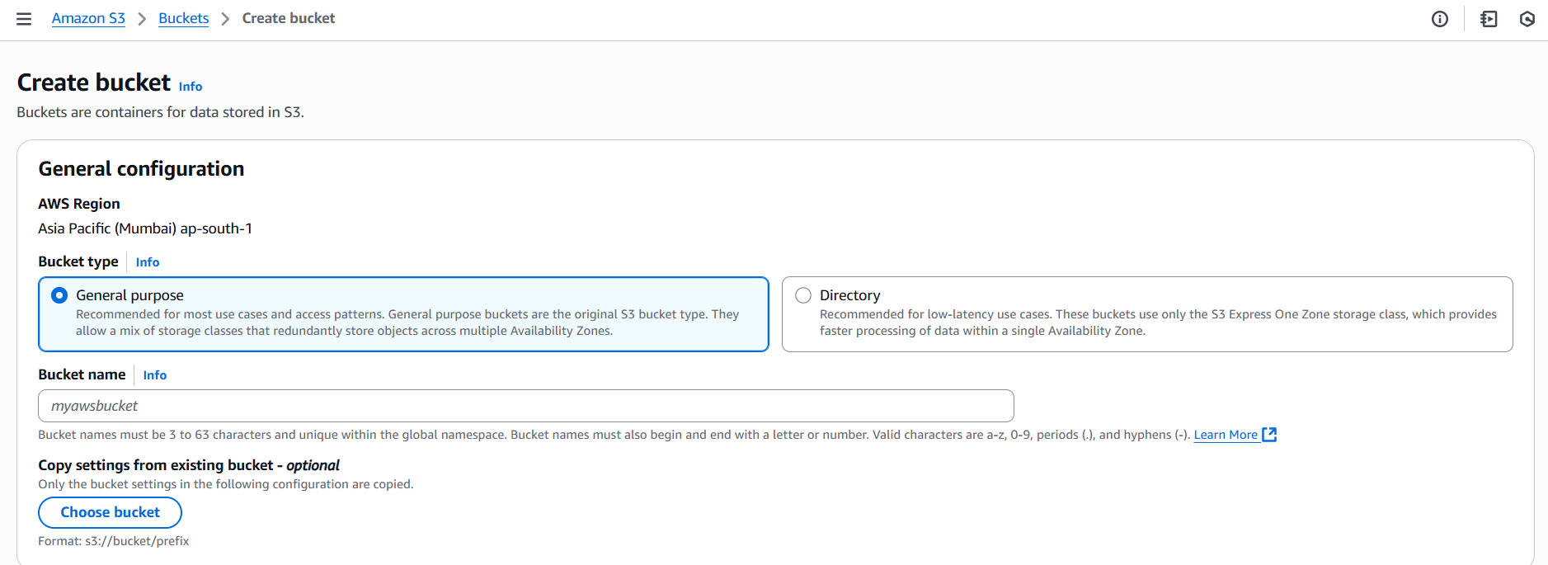

🔹 2. Click “Create Bucket”

You’ll land on the Create bucket page, as shown in your screenshot.

🧾 Fill in the following:

• Bucket name: Choose a globally unique name like

• AWS Region: Select for local latency

• Bucket type:

• ✅ Select General purpose (recommended for most use cases)

• Copy settings from existing bucket: Leave this unchecked unless you want to replicate settings

Click Next or Create bucket (depending on your console version).

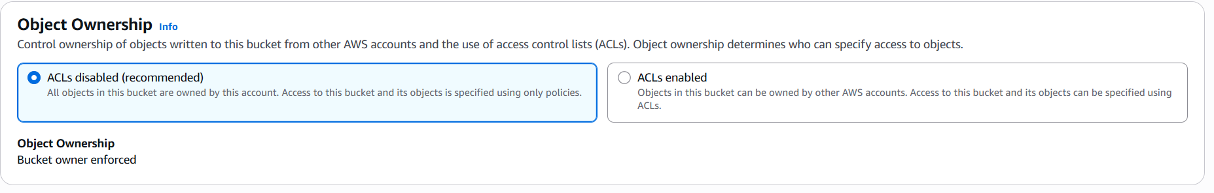

🔹 3. Configure Bucket Settings (Post-Creation)

Once the bucket is created:

• Go to Properties

• Scroll to Static website hosting

• Enable it and set:

• Index document:

• Error document: (optional)

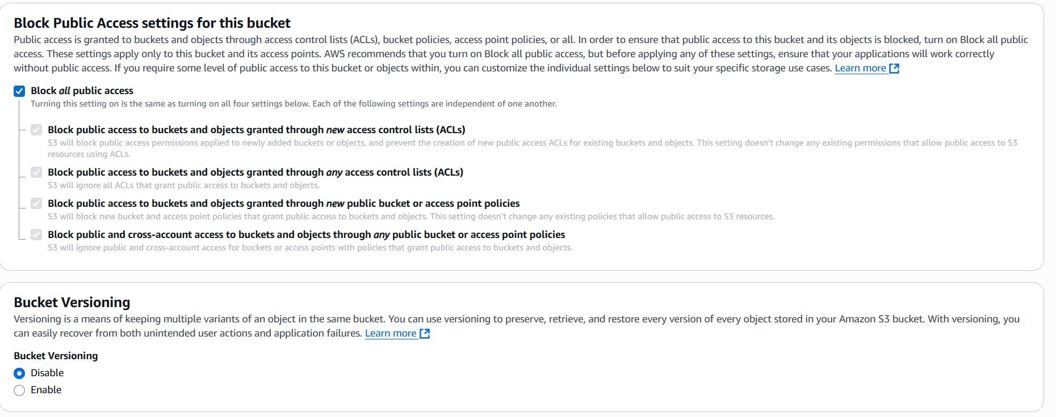

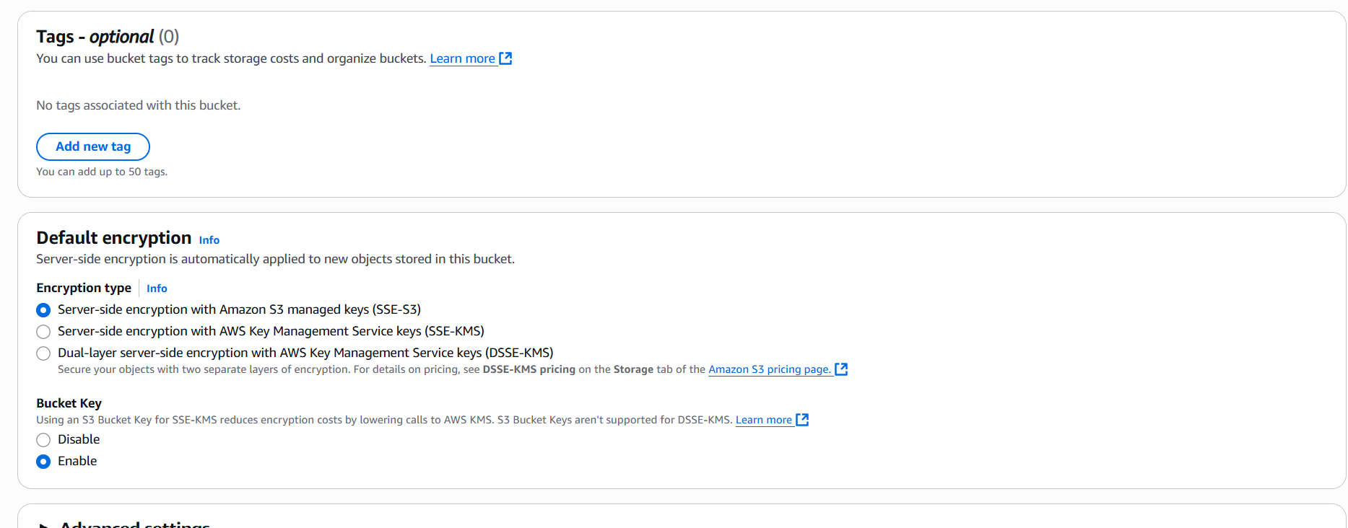

🔹 4. Upload Your Website Files

• Go to the Objects tab

• Click Upload

• Add your HTML, CSS, JS files

• Click Upload again to confirm

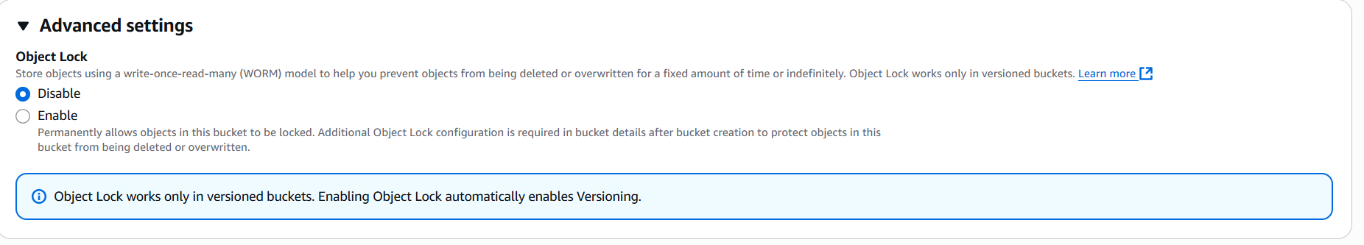

🔹 5. Set Bucket Policy for Public Access

Go to Permissions → Bucket Policy, and paste:

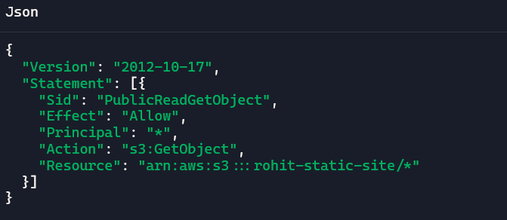

Replace with your actual bucket name.

🔹 6. Access Your Website

• Go to Properties → Static website hosting

• Copy the Endpoint URL

• Open it in your browser to view your hosted site